Project Design Phase-II

Data Flow Diagram & User Stories

# Data Flow Diagrams:

A Data Flow Diagram (DFD) is a traditional visual representation of the information flows within a system. A neat and clear DFD can depict the right amount of the system requirement graphically. It shows how data enters and leaves the system, what changes the information, and where data is stored.

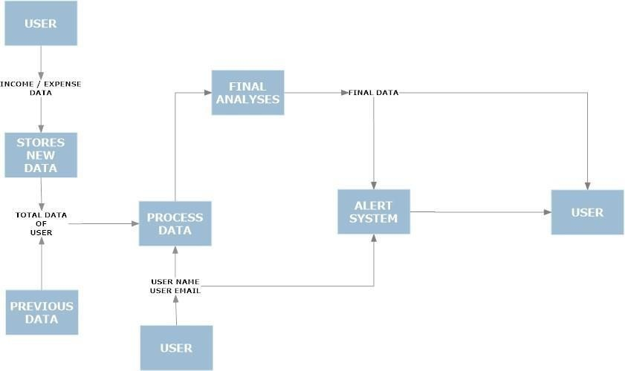

# User Stories

Use the below template to list all the user stories for the product.

|  |  |  |  |  |  |  |
| --- | --- | --- | --- | --- | --- | --- |
| **User Type** | **Functional Requirement**  **(Epic)** | **User Story Number** | **User Story / Task** | **Acceptance criteria** | **Priority** | **Release** |
| Customer  (Mobile user & web user ) | Registration | USN-1 | As a user, I can register for the application by  entering my email, password, and confirming my password. | I can access my account / dashboard | High |  |
|  |  | USN-2 | As a user, I will receive confirmation email once I have registered for the application | I can receive confirmation email & click confirm | High |  |
|  |  | USN- 3 | As a user, I can register for the application through Facebook | I can register & access the dashboard with Facebook Login | Low |  |
|  | Login | USN - 4 | As a user, I can log into the application by entering email & password | I can access the application | High |  |
|  | Dashboard | USN - 5 | As a user I can enter my income and  expenditure details. | I can view my daily  expenses | High |  |
| Customer Care Executive |  | USN – 6 | As a customer care executive I can solve the log in issues and other issues of the  application. | I can provide support or solution at any time 24*7 | Medium |  |
| Administrator | Application | USN - 7 | As a administrator I can upgrade or update the application. | I can fix the bug which arises for the customers  and users of the application | Medium |  |